# [***80 FR 47517***](https://advance.lexis.com/api/document?collection=administrative-codes&id=urn:contentItem:5GMD-6NR0-006W-82P1-00000-00&context=)

Vol. 80, No. 152, Friday, August 7, 2015

Notices

**Reporter**

80 FR 47517 *

***Federal Register* > *2015* > *August* > *Friday, August 7, 2015* > *Notices* > *DEPARTMENT OF JUSTICE (DOJ) -- Antitrust Division***

**Title:** **United States and State of New York v. Twin America, LLC, et al.; Public Comment and Response on Proposed Final Judgment**

**Agency**

DEPARTMENT OF JUSTICE (DOJ) > ***Antitrust*** Division

**Text**

Pursuant to the ***Antitrust*** Procedures and Penalties Act, [*15 U.S.C. 16(b)*](https://advance.lexis.com/api/document?collection=statutes-legislation&id=urn:contentItem:4YF7-GR31-NRF4-44X5-00000-00&context=)-(h), the United States hereby publishes below the comment received on the proposed Final Judgment in *United States and State of New York* v. *Twin America, LLC, et al.,* Civil Action No. 12-cv-8989 (ALC) (GWG) (S.D.N.Y.), together with the Response of the United States to Public Comment.

Copies of the comment and the United States' Response are available for inspection at the Department of Justice ***Antitrust*** Division, 450 Fifth Street NW., Suite 1010, Washington, DC 20530 (telephone: 202-514-2481), on the Department of Justice's Web site at **[*47518]** [*http://www.justice.gov/atr/case/us-and-state-new-york-v-twin-america-llc-et-al*](http://www.justice.gov/atr/case/us-and-state-new-york-v-twin-america-llc-et-al)*,* and at the Office of the Clerk of the United States District Court for the Southern District of New York, Daniel Patrick Moynihan United States Courthouse, 500 Pearl Street, New York, NY 10007. Copies of any of these materials may also be obtained upon request and payment of a copying fee.

**Patricia A. Brink,**

*Director of Civil Enforcement.*

**UNITED STATES DISTRICT COURT FOR THE SOUTHERN DISTRICT OF NEW YORK**

UNITED STATES OF AMERICA, AND STATE OF NEW YORK, *Plaintiffs,* v. TWIN AMERICA, LLC, et al. *Defendants.*

Civil Action No. 12-cv-8989 (ALC) (GWG)

ECF Case

**RESPONSE OF PLAINTIFF UNITED STATES TO PUBLIC COMMENT ON THE PROPOSED FINAL JUDGMENT**

Pursuant to the requirements of the ***Antitrust*** Procedures and Penalties Act, [*15 U.S.C. 16(b)*](https://advance.lexis.com/api/document?collection=statutes-legislation&id=urn:contentItem:4YF7-GR31-NRF4-44X5-00000-00&context=)-(h) ("Tunney Act"), the United States hereby files the single public comment received concerning the proposed Final Judgment in this case and the United States' response to the comment. After careful consideration of the submitted comment, the United States continues to believe that the proposed Final Judgment provides an effective and appropriate remedy for the violations alleged in the Complaint. The United States will move the Court for entry of the proposed Final Judgment after the public comment and this Response have been published in the **Federal Register** pursuant to [*15 U.S.C. 16(d)*](https://advance.lexis.com/api/document?collection=statutes-legislation&id=urn:contentItem:4YF7-GR31-NRF4-44X5-00000-00&context=).

**I. PROCEDURAL HISTORY**

On March 17, 2009, Defendants Coach USA, Inc. (through subsidiary International Bus Services, Inc.) and CitySights LLC (through subsidiary City Sights Twin, LLC) formed Twin America, LLC ("Twin America"), a joint venture that combined their hop-on, hop-off bus tour operations in New York City.

Defendants subsequently applied to the federal Surface Transportation Board ("STB") for approval of the Twin America transaction, which would have conferred ***antitrust*** immunity. After more than two years of proceedings, the STB rejected the joint venture as anticompetitive. However, while Defendants ceased operating the nominal interstate service that had formed the basis for the STB's jurisdiction, they continued operating their hop-on, hop-off bus tour operations in New York City.

In December 2012, the United States and the State of New York (collectively, "Plaintiffs") filed this civil ***antitrust*** action, alleging that the formation of Twin America substantially lessened ***competition*** in the market for hop-on, hop-off bus tours in New York City in violation of Section 7 of the Clayton Act, [*15 U.S.C. 18*](https://advance.lexis.com/api/document?collection=statutes-legislation&id=urn:contentItem:4YF7-GNT1-NRF4-426N-00000-00&context=), and also violated Section 1 of the Sherman Act, *15 U.S.C. 1*, Section 340 of the Donnelly Act, N.Y. Gen. Bus. Law § 340, and Section 63(12) of the New York Executive Law, N.Y. Exec. Law § 63(12). The Complaint sought to remedy the harm to ***competition*** and disgorge the ill-gotten gains Defendants had obtained from operating Twin America in violation of the ***antitrust*** laws.

In December 2014, the parties adjourned a February 2015 trial date to facilitate settlement discussions. These discussions culminated in the proposed Final Judgment, which was filed on March 16, 2015 (Dkt. No. 127-1). n1 As required by the Tunney Act, the United States published the proposed Final Judgment and ***Competitive*** Impact Statement in the **Federal Register** on March 27, 2015, [*80 FR 16427*](https://advance.lexis.com/api/document?collection=administrative-codes&id=urn:contentItem:5FM1-TX70-006W-82S2-00000-00&context=) (Mar. 27, 2015), and caused to be published summaries of the terms of the proposed Final Judgment and ***Competitive*** Impact Statement, together with directions for the submission of written comments relating to the proposed Final Judgment, in *The Washington Post* and the *New York Daily News* for seven days (March 24 through March 30, 2015). The 60-day period for public comments ended on May 29, 2015. The United States received one comment, which is described below and attached hereto as Exhibit 1.

n1 In October 2014, this Court approved Defendants' settlement of related class action lawsuits. *See* Order and Final Judgment Approving *In Re NYC Bus Tour* ***Antitrust*** *Litigation* Class Action Settlement, *In re NYC Bus Tour* ***Antitrust*** *Litigation,* No. 13-CV-0711 (ALC) (GWG) (S.D.N.Y. Oct. 21, 2014) (Dkt. No. 122).

**II. THE PROPOSED SETTLEMENT**

The Complaint alleged that the formation of Twin America had the purpose and effect of creating a monopoly in the hop-on, hop-off bus tour market in New York City. The joint venture eliminated substantial head-to-head ***competition*** between Coach and City Sights that had benefitted consumers in the form of discounts, increased product offerings, and service improvements. The joint venture also enabled Defendants to increase hop-on, hop-off bus tour prices by approximately 10%, resulting in immediate and continuing harm to consumers.

The Complaint alleged that entry of new firms into the market or expansion of existing firms was unlikely to counteract the ***competitive*** harm caused by the formation and operation of Twin America. According to the Complaint, the primary barrier to entry was the difficulty of obtaining hop-on, hop-off bus stop authorizations from the New York City Department of Transportation ("NYCDOT"). Bus stop authorizations are required by NYCDOT for each location a tour operator wishes to load and unload passengers. Defendants obtained a robust portfolio of bus stop authorizations from NYCDOT several years ago, including authorizations at or very close to virtually all of Manhattan's major tourist attractions. Recent entrants, by contrast, were consistently unable to obtain ***competitive*** bus stop authorizations from NYCDOT at top tourist attractions because NYCDOT allocated such authorizations on a "first come, first served" basis and most ***competitive*** bus stop locations were already at capacity or otherwise unavailable. As a result, more than five years after Twin America's formation, the joint venture still dominated the market and Defendants had sustained their anticompetitive price increases.

The proposed Final Judgment addresses the harm alleged in the Complaint by requiring Twin America to divest all of City Sights's bus stop authorizations in Manhattan to NYCDOT, the city agency charged with managing bus stop authorizations. The divestiture significantly eases the primary entry barrier alleged in the Complaint by increasing NYCDOT's inventory of bus stops, including for the locations most sought by recent entrants. City Sights's set of approximately 50 bus stops includes highly-coveted stops surrounding key tourist attractions such as Times Square, the Empire State Building, and Battery Park that are critical to operating a ***competitive*** hop-on, hop-off bus tour. The proposed Final Judgment also prohibits Defendants from applying for or obtaining any bus stop authorizations for hop-on, hop-off bus tours at the locations of the divested City Sights bus stop authorizations for five years, subject to limited exceptions. In compliance with the proposed Final Judgment, Defendants relinquished the City Sights bus stop authorizations to NYCDOT on April 30, 2015.

The proposed Final Judgment also requires Defendants to pay $ 7.5 million in disgorgement to the United States and State of New York, which is on top **[*47519]** of the payments made by Defendants to settle the class action.

**III. STANDARD OF JUDICIAL REVIEW UNDER THE TUNNEY ACT**

The Tunney Act requires that proposed consent judgments in ***antitrust*** cases brought by the United States be subject to a 60-day public comment period, after which the court shall determine whether entry of the proposed Final Judgment "is in the public interest." [*15 U.S.C. 16(e)(1)*](https://advance.lexis.com/api/document?collection=statutes-legislation&id=urn:contentItem:4YF7-GR31-NRF4-44X5-00000-00&context=); *see also* [*United States v. Apple, Inc., 889 F. Supp. 2d 623, 630 (S.D.N.Y. 2012);*](https://advance.lexis.com/api/document?collection=cases&id=urn:contentItem:56HF-7M51-F04F-00W0-00000-00&context=) [*United States v. Morgan Stanley, 881 F. Supp. 2d 563, 566 (S.D.N.Y. 2012).*](https://advance.lexis.com/api/document?collection=cases&id=urn:contentItem:56B6-VBN1-F04F-0433-00000-00&context=) In making that determination, the court, in accordance with the statute as amended in 2004, is required to consider:

(A) the ***competitive*** impact of such judgment, including termination of alleged violations, provisions for enforcement and modification, duration of relief sought, anticipated effects of alternative remedies actually considered, whether its terms are ambiguous, and any other ***competitive*** considerations bearing upon the adequacy of such judgment that the court deems necessary to a determination of whether the consent judgment is in the public interest; and

(B) the impact of entry of such judgment upon ***competition*** in the relevant market or markets, upon the public generally and individuals alleging specific injury from the violations set forth in the complaint including consideration of the public benefit, if any, to be derived from a determination of the issues at trial.

[*15 U.S.C. 16(e)(1)*](https://advance.lexis.com/api/document?collection=statutes-legislation&id=urn:contentItem:4YF7-GR31-NRF4-44X5-00000-00&context=); *see also* [*Apple, 889 F. Supp. 2d at 630-31;*](https://advance.lexis.com/api/document?collection=cases&id=urn:contentItem:56HF-7M51-F04F-00W0-00000-00&context=) [*Morgan Stanley, 881 F. Supp. 2d at 566-67.*](https://advance.lexis.com/api/document?collection=cases&id=urn:contentItem:56B6-VBN1-F04F-0433-00000-00&context=)

In considering these statutory factors, the court's inquiry is necessarily a limited one. [*Apple, 889 F. Supp. 2d at 631;*](https://advance.lexis.com/api/document?collection=cases&id=urn:contentItem:56HF-7M51-F04F-00W0-00000-00&context=) [*Morgan Stanley, 881 F. Supp. 2d at 567;*](https://advance.lexis.com/api/document?collection=cases&id=urn:contentItem:56B6-VBN1-F04F-0433-00000-00&context=) [*United States v. Keyspan Corp., 763 F. Supp. 2d 633, 637 (S.D.N.Y. 2011).*](https://advance.lexis.com/api/document?collection=cases&id=urn:contentItem:524W-GHY1-652J-D25B-00000-00&context=) A court should consider, among other things, the relationship between the remedy secured and the specific allegations set forth in the Complaint, whether the decree is sufficiently clear, whether the enforcement mechanisms are sufficient, and whether the decree may positively harm third parties. [*Apple, 889 F. Supp. 2d at 631;*](https://advance.lexis.com/api/document?collection=cases&id=urn:contentItem:56HF-7M51-F04F-00W0-00000-00&context=) [*United States v. Microsoft Corp., 56 F.3d 1448, 1458-62 (D.C. Cir. 1995).*](https://advance.lexis.com/api/document?collection=cases&id=urn:contentItem:3RTP-83N0-001T-D0C7-00000-00&context=) However, "[a] court must limit its review to the issues in the complaint and give due respect to the [Government's] perception of . . . its case[.]' " [*Morgan Stanley, 881 F. Supp. 2d at 567*](https://advance.lexis.com/api/document?collection=cases&id=urn:contentItem:56B6-VBN1-F04F-0433-00000-00&context=) (quoting [*Microsoft, 56 F.3d at 1461);*](https://advance.lexis.com/api/document?collection=cases&id=urn:contentItem:3RTP-83N0-001T-D0C7-00000-00&context=) *see also* [*Keyspan, 763 F. Supp. 2d at 638*](https://advance.lexis.com/api/document?collection=cases&id=urn:contentItem:524W-GHY1-652J-D25B-00000-00&context=) (same); [*Apple, 889 F. Supp. 2d at 631*](https://advance.lexis.com/api/document?collection=cases&id=urn:contentItem:56HF-7M51-F04F-00W0-00000-00&context=) ("In most cases, the court is not permitted to reach beyond the complaint to evaluate claims that the government did *not* make.") (internal quotation omitted).

"The role of the court is not to determine whether the decree results in the array of rights and liabilities that will *best* serve society, but only to ensure that the resulting settlement is within the *reaches* of the public interest.'" [*Apple, 889 F. Supp. 2d at 631*](https://advance.lexis.com/api/document?collection=cases&id=urn:contentItem:56HF-7M51-F04F-00W0-00000-00&context=) (quoting [*Keyspan, 763 F. Supp. 2d at 637)*](https://advance.lexis.com/api/document?collection=cases&id=urn:contentItem:524W-GHY1-652J-D25B-00000-00&context=) (emphasis in original); *see also* [*Morgan Stanley, 881 F. Supp. 2d at 567;*](https://advance.lexis.com/api/document?collection=cases&id=urn:contentItem:56B6-VBN1-F04F-0433-00000-00&context=) [*Microsoft, 56 F.3d at 1460;*](https://advance.lexis.com/api/document?collection=cases&id=urn:contentItem:3RTP-83N0-001T-D0C7-00000-00&context=) [*United States v. BNS, Inc., 858 F.2d 456, 462 (9th Cir. 1988)*](https://advance.lexis.com/api/document?collection=cases&id=urn:contentItem:3S4W-Y8S0-001B-K1MJ-00000-00&context=) (explaining court may not "engage in an unrestricted evaluation of what relief would best serve the public"); [*United States v. Bechtel Corp., 648 F.2d 660, 666 (9th Cir. 1981)*](https://advance.lexis.com/api/document?collection=cases&id=urn:contentItem:3S4X-16H0-0039-W1PJ-00000-00&context=) (noting that "court is required to determine not whether a particular decree is the one that will best serve society, but whether the settlement is within the reaches of the public interest") (citations omitted).

In determining whether a proposed settlement is in the public interest, "the court should be deferential to the government's predictions as to the effect of the proposed remedies.' " [*Apple, 889 F. Supp. 2d at 631*](https://advance.lexis.com/api/document?collection=cases&id=urn:contentItem:56HF-7M51-F04F-00W0-00000-00&context=) (quoting [*Microsoft, 56 F.3d at 1461);*](https://advance.lexis.com/api/document?collection=cases&id=urn:contentItem:3RTP-83N0-001T-D0C7-00000-00&context=) *see also* [*United States v. US Airways Grp., Inc., 38 F. Supp. 3d 69, 76 (D.D.C. 2014)*](https://advance.lexis.com/api/document?collection=cases&id=urn:contentItem:5C2F-7GX1-F04C-Y0FY-00000-00&context=) ("must accord deference to the government's predictions about the efficacy of its remedies") (quoting [*United States v. SBC Commc'ns, Inc., 489 F. Supp. 2d 1, 17 (D.D.C. 2007));*](https://advance.lexis.com/api/document?collection=cases&id=urn:contentItem:4NCK-65B0-TVT3-D3DR-00000-00&context=) [*United States v. Archer-Daniels-Midland Co., 272 F. Supp. 2d 1, 6 (D.D.C. 2003)*](https://advance.lexis.com/api/document?collection=cases&id=urn:contentItem:494T-VD60-0038-Y0P1-00000-00&context=) (noting that the court should grant due respect to the United States' "prediction as to the effect of proposed remedies, its perception of the market structure, and its view of the nature of the case").

A court "is not permitted to reject the proposed remedies merely because the court believes other remedies are preferable." [*Keyspan, 763 F. Supp. 2d at 637;*](https://advance.lexis.com/api/document?collection=cases&id=urn:contentItem:524W-GHY1-652J-D25B-00000-00&context=) *see also* [*Apple, 889 F. Supp. 2d at 631*](https://advance.lexis.com/api/document?collection=cases&id=urn:contentItem:56HF-7M51-F04F-00W0-00000-00&context=) (same); *United States v. Am. Tel. & Tel. Co., 552 F. Supp. 131, 151 (D.D.C. 1982)* (stating that "proposed decree must be approved even if it falls short of the remedy the court would impose on its own, as long as it falls within the range of acceptability or is within the reaches of the public interest") (citations and internal quotations omitted); *United States v. Alcan Aluminum Ltd., 605 F. Supp. 619, 622 (W.D. Ky. 1985)* (approving consent decree even though the court would have imposed greater remedy).

The relevant inquiry "is whether the Government has established an ample factual foundation for [its] decisions such that its conclusions regarding the proposed settlement are reasonable.' " [*Apple, 889 F. Supp. 2d at 631*](https://advance.lexis.com/api/document?collection=cases&id=urn:contentItem:56HF-7M51-F04F-00W0-00000-00&context=) (quoting [*Keyspan, 763 F. Supp. 2d at 637-38);*](https://advance.lexis.com/api/document?collection=cases&id=urn:contentItem:524W-GHY1-652J-D25B-00000-00&context=) *see also* [*Microsoft, 56 F.3d at 1461*](https://advance.lexis.com/api/document?collection=cases&id=urn:contentItem:3RTP-83N0-001T-D0C7-00000-00&context=) (assessing whether "the remedies [obtained in the decree are] so inconsonant with the allegations charged as to fall outside of the reaches of the public interest.' "); [*SBC Commc'ns, 489 F. Supp. 2d at 17*](https://advance.lexis.com/api/document?collection=cases&id=urn:contentItem:4NCK-65B0-TVT3-D3DR-00000-00&context=) (explaining that courts "may not require that the remedies perfectly match the alleged violations"). Accordingly, the United States "need only provide a factual basis for concluding that the settlements are reasonably adequate remedies for the alleged harms." [*SBC Commc'ns, 489 F. Supp. 2d at 17;*](https://advance.lexis.com/api/document?collection=cases&id=urn:contentItem:4NCK-65B0-TVT3-D3DR-00000-00&context=) *see also* [*Apple, 889 F. Supp. 2d at 631.*](https://advance.lexis.com/api/document?collection=cases&id=urn:contentItem:56HF-7M51-F04F-00W0-00000-00&context=)

In its 2004 amendments to the Tunney Act, n2 Congress made clear its intent to preserve the practical benefits of using consent decrees in ***antitrust*** enforcement, adding the unambiguous instruction that "[n]othing in this section shall be construed to require the court to conduct an evidentiary hearing or to require the court to permit anyone to intervene." [*15 U.S.C. 16(e)(2)*](https://advance.lexis.com/api/document?collection=statutes-legislation&id=urn:contentItem:4YF7-GR31-NRF4-44X5-00000-00&context=); *see also* [*Apple, 889 F. Supp. 2d at 631*](https://advance.lexis.com/api/document?collection=cases&id=urn:contentItem:56HF-7M51-F04F-00W0-00000-00&context=) ("The Tunney Act allows, but does not require, the court to conduct an evidentiary hearing and to permit third parties to intervene."). The procedure for the public-interest determination is left to the discretion of the court, with the recognition that the court's "scope of review remains sharply proscribed by precedent and the nature of Tunney Act proceedings." [*SBC Commc'ns, 489 F. Supp. 2d at 11.*](https://advance.lexis.com/api/document?collection=cases&id=urn:contentItem:4NCK-65B0-TVT3-D3DR-00000-00&context=) "A court can make its public interest determination based on the ***competitive*** impact statement and response to public comments alone." [*US Airways, 38 F. Supp. 3d at 76.*](https://advance.lexis.com/api/document?collection=cases&id=urn:contentItem:5C2F-7GX1-F04C-Y0FY-00000-00&context=)

n2 The 2004 amendments substituted "shall" for "may" in directing relevant factors for courts to consider and amended the list of factors to focus on ***competitive*** considerations and to address potentially ambiguous judgment terms. *Compare* [*15 U.S.C. 16(e)*](https://advance.lexis.com/api/document?collection=statutes-legislation&id=urn:contentItem:4YF7-GR31-NRF4-44X5-00000-00&context=) (2004), *with* [*15 U.S.C. 16(e)(1)*](https://advance.lexis.com/api/document?collection=statutes-legislation&id=urn:contentItem:4YF7-GR31-NRF4-44X5-00000-00&context=) (2006); *see also* [*SBC Commc'ns, 489 F. Supp. 2d at 11*](https://advance.lexis.com/api/document?collection=cases&id=urn:contentItem:4NCK-65B0-TVT3-D3DR-00000-00&context=) (concluding that the 2004 amendments "effected minimal changes" to Tunney Act review).

**IV. UNITED STATES' RESPONSE TO PUBLIC COMMENT**

The United States received one public comment, from Taxi Tours, Inc., doing business as BigBus ("Big Bus"). Big Bus entered the New York City hop-on, hop-off bus tour market in 2014 by acquiring an existing player, Big Taxi. The comment makes four principal points: (1) There should be additional remedies to facilitate ***competitors***' ticket sales; (2) there should be a more specific process governing the allocation of bus stop authorizations; (3) the judgment should apply to Defendants' future affiliated **[*47520]** entities; and (4) there should be a process for third parties to report violations of the Final Judgment. The United States respectfully responds to each point below.

**1. Divestiture of the City Sights bus stops is sufficient to remedy the harm alleged in the Complaint**

Big Bus's comment asserts that Defendants prevent ***competitors*** from selling tickets for hop-on, hop-off bus tours at or near certain key tourist attractions and proposes that the settlement be amended to ensure equal access to vendors to market and sell tickets from Defendants' ***competitors***. Big Bus also expresses concerns regarding the conduct of City Experts, an affiliate of Defendants that offers tourists a variety of tours and attractions from concierge desks it operates at certain New York City hotels. Big Bus contends that because City Experts sells Defendants' hop-on, hop-off bus tours as part of its bundled tourism packages but not the hop-on, hop-off bus tours of Defendants' ***competitors***, it "prevents the Defendants' ***competitors*** from effectively ***competing*** at the hotel and retail level." Big Bus also complains that Twin America's employees prevent Big Bus staff from selling tickets by verbally and physically attacking them.

Pursuant to the Tunney Act, review of a proposed Final Judgment is limited to the relationship of the remedy to the violations alleged in the Complaint. *See* [*Microsoft, 56 F.3d at 1459-61;*](https://advance.lexis.com/api/document?collection=cases&id=urn:contentItem:3RTP-83N0-001T-D0C7-00000-00&context=) [*Morgan Stanley, 881 F. Supp. 2d at 567;*](https://advance.lexis.com/api/document?collection=cases&id=urn:contentItem:56B6-VBN1-F04F-0433-00000-00&context=) [*Keyspan, 763 F. Supp. 2d at 637-38;*](https://advance.lexis.com/api/document?collection=cases&id=urn:contentItem:524W-GHY1-652J-D25B-00000-00&context=) [*Apple, 889 F. Supp. 2d at 631.*](https://advance.lexis.com/api/document?collection=cases&id=urn:contentItem:56HF-7M51-F04F-00W0-00000-00&context=) As described above, the Complaint alleged that the formation and operation of Twin America substantially lessened ***competition*** in the hop-on, hop-off bus tour market in New York City and identified potential entrants' inability to obtain bus stop authorizations at or sufficiently near top tourist attractions as the primary entry barrier. The proposed settlement addresses this entry barrier by requiring Twin America to divest all of the approximately 50 City Sights bus stop authorizations in Manhattan, including highly desirable stops at or near key tourist attractions that rivals have been consistently unable to obtain. By relinquishing all of the City Sights bus stops to NYCDOT, the proposed Final Judgment increases the available inventory of bus stops for which rivals can obtain the authorizations needed to effectively ***compete*** with Twin America.

The Complaint did not allege that the conduct of Defendants' street sellers, its City Experts affiliate, or Defendants' sales practices otherwise served as a meaningful barrier to ***competition*** in the hop-on, hop-off bus tour market. Nor did the Complaint allege that the formation of the joint venture had an impact on these practices. Thus, the suggested additional provisions are unnecessary to address the ***competitive*** harm set forth in the Complaint.

**2. NYCDOT administers bus stop authorizations**

Big Bus argues that the proposed settlement should establish certain rules and processes related to the allocation and use of hop-on, hop-off bus stops. First, Big Bus asserts that the Final Judgment "should define a fair and monitored process of reassignment/reallocation of the divested [City Sights bus stop] authorizations to ensure that all ***competitors*** in the relevant market have an equal opportunity to apply for the divested stop authorizations." Big Bus also claims that the Final Judgment should address how hop-on, hop-off bus stop authorizations would be handled in the event that Defendants acquired an existing hop-on, hop-off bus tour business.

Procedures relating to the assignment and allocation of bus stop authorizations are within the jurisdiction of NYCDOT, the New York City agency charged with regulating and managing bus stops. *See, e.g.,* NYC Charter § 2903 (giving NYCDOT control of and responsibility for "all those functions and operations of the city relating to transportation"); NYC Charter § 2903(a)(14) (empowering NYCDOT to enforce rules and ***regulations*** regarding vehicular traffic and the parking, standing, or stopping of vehicles on the city's streets); 34 RCNY § 4-10 (governing the operations of buses in the city and providing that bus operators, subject to certain exceptions, cannot "pick up or discharge passengers on a street except at a bus stop designated by the Commissioner [of NYCDOT] in writing."). Pursuant to this authority, NYCDOT is best positioned to determine how to distribute the City Sights bus stops that have been relinquished pursuant to the proposed Final Judgment, taking into account the relevant factors just as it does with respect to bus stop allocations and authorizations generally.

Given the established NYCDOT role in bus stop authorizations and allocations, the United States concluded that the facts of this case did not call for the proposed Final Judgment to establish any additional ***regulations*** or processes relating to the assignment or allocation of bus stop authorizations.

**3. The proposed settlement already covers affiliated entities**

Big Bus's comment raises a concern that two provisions of the proposed Final Judgment--having to do with notification to the government of certain transactions (Section X) and "reacquisition" of stops (Section XII)--would not apply to affiliated entities that Defendants might form after entry of the Final Judgment. Big Bus is incorrect. The proposed Final Judgment applies to Defendant entities as well as their " *successors and assigns,* and any subsidiaries, divisions, groups, affiliates, partnerships and joint ventures under their control, and their directors, officers, managers, agents, and employees" (emphasis added). Therefore, any entities that Defendants form or acquire after entry of the Final Judgment will also be subject to it.

**4. Third parties may report violations of the Final Judgment to the United States or State of New York**

Finally, Big Bus argues that Section XIII of the proposed Final Judgment, which provides that the Court retains jurisdiction for ten years to monitor and enforce the terms of the Final Judgment, should also set forth "a process whereby third parties may directly report violations of the Final Judgment by the Defendants." The United States does not believe this is necessary. Third parties can already report such violations to the ***Antitrust*** Division of the Department of Justice or the ***Antitrust*** Bureau of the New York Attorney General's Office. Plaintiffs will take the appropriate steps to respond to any reported violations, including by applying to the Court to enforce compliance or punish violations pursuant to Section XIII of the proposed Final Judgment.

**V. CONCLUSION**

After carefully reviewing the public comment submitted by Big Bus, the United States has determined that the proposed Final Judgment, as drafted, provides an effective and appropriate remedy for the ***antitrust*** violation alleged in the Complaint and is therefore in the public interest. The United States will move this Court to enter the proposed Final Judgment after the public comment and this Response have been published in the **Federal Register** .

Dated: July 28, 2015

Respectfully submitted,

/s/

Sarah Oldfield

David E. Altschuler

*U.S. Department of Justice,* ***Antitrust*** *Division, Transportation, Energy &* ***[*47521]*** *Agriculture Section, 450 Fifth Street NW., Suite 8000, Washington, DC 20530, Telephone: (202) 305-8915,* [*Sarah.Oldfield@usdoj.gov*](mailto:Sarah.Oldfield@usdoj.gov)*,* [*David.Altschuler@usdoj.gov*](mailto:David.Altschuler@usdoj.gov).

Benjamin Sirota

*U.S. Department of Justice,* ***Antitrust*** *Division, New York Office, 26 Federal Plaza, Room 3630, New York, NY 10278, Telephone: (212) 335-8056,* [*Benjamin.Sirota@usdoj.gov*](mailto:Benjamin.Sirota@usdoj.gov).

*Attorneys for Plaintiff United States* **[*47522]**

**[*47523]**

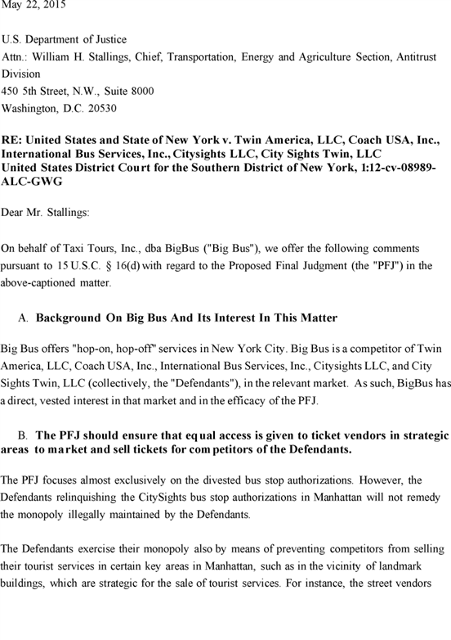

**[*47523]**



**[*47524]**

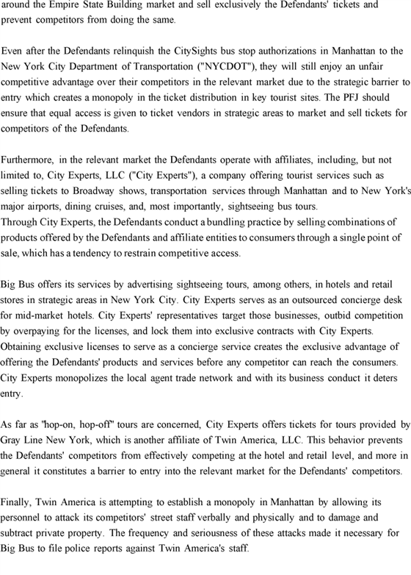

**[*47524]**



**[*47525]**

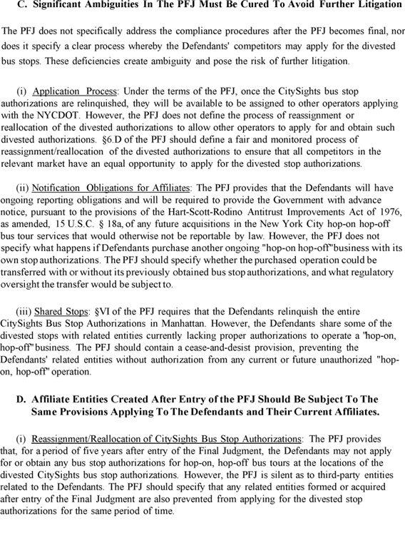

**[*47525]**

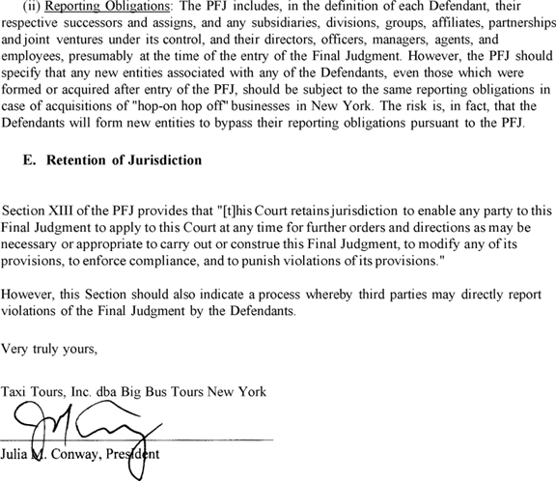

[FR Doc. 2015-19495 Filed 8-6-15; 8:45 am]

BILLING CODE P

FEDERAL REGISTER

**End of Document**